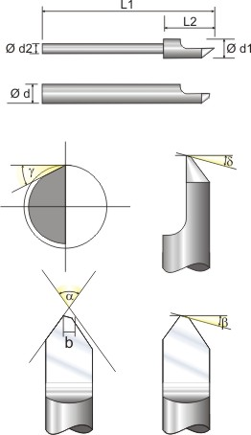

Finish: | - Shape: V-shaped, cylindrical, round, individual form.  - Single or double-sided design  - Halved or quartered  - Material  -. Optionally coating
Geometry: | - Diameter, length, halving length  - Optionally tapered shank  - Possibly exposed shaft.
Tip: | - Type of tip  - Side clearance angle γ  - Secondary clearance angle β and δ  - Cutting width b
We also manufacture Scratching tool for electronics as well as scribing and puncture needles for various purposes.

