BENCH TEST ON 18th May
I put a 1.5V button cell battery in the vernier to stabilise but made no difference to erratic PC display read out. All PSU rails look good and noise free. See step by step below.

Some Measurements

This is a view of the Txd to the RS232 (collector of PNP transistor) top trace and the BCD data from the vernier bottom trace. The RS232 is 10.4 V p-p but skewed around PC ground (+3V to -7V). The data is 1.56 V p-p

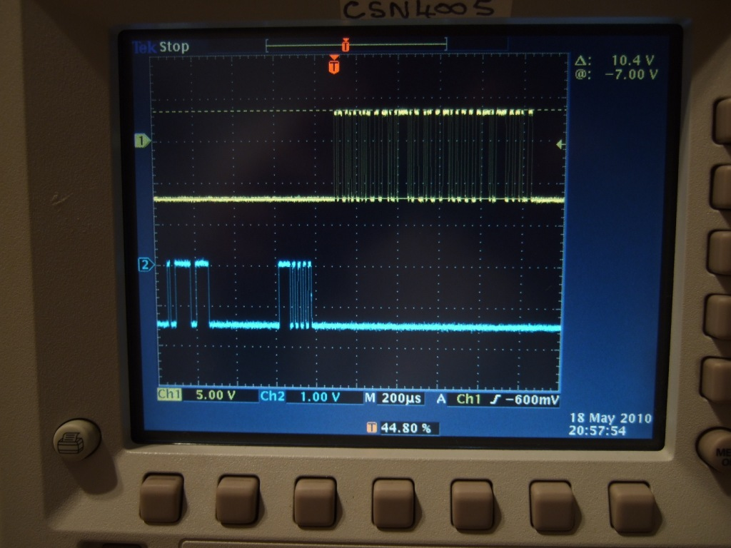

The next view is the same but delay between data and PIC output burst is different. This may be a triggering issue on the scope – not sure (the ALT/chop problem maybe?)
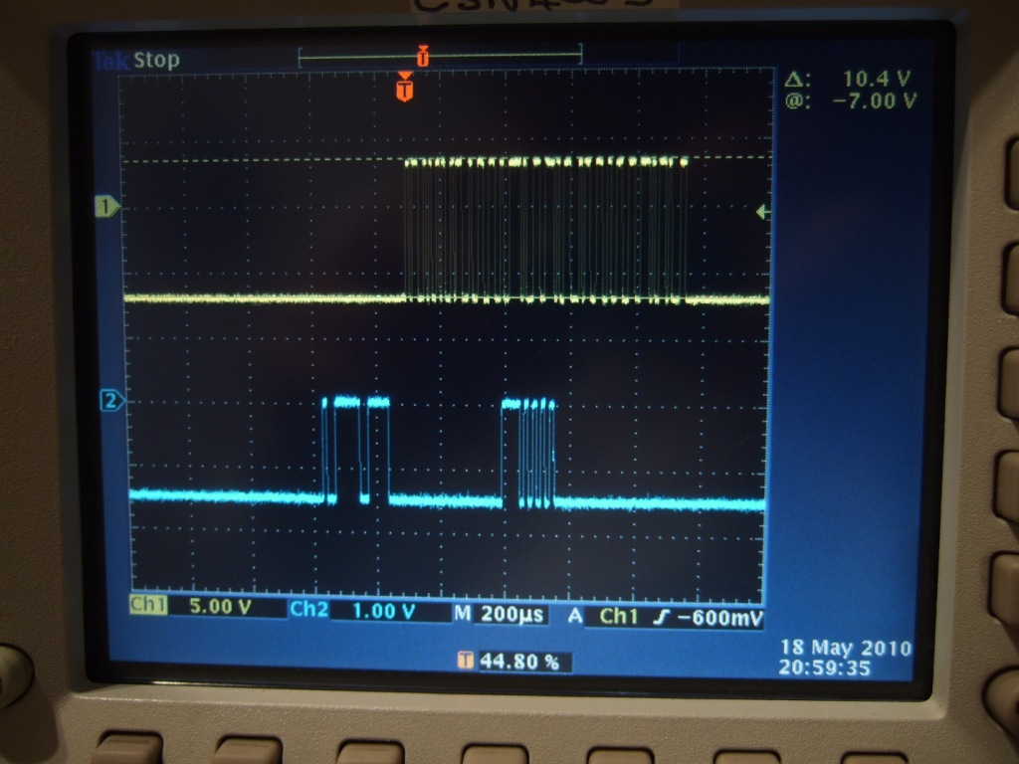

The next view is the Vernier detailed output. All very stable. Not sure about the extra data bits at the end when clock is not toggling?

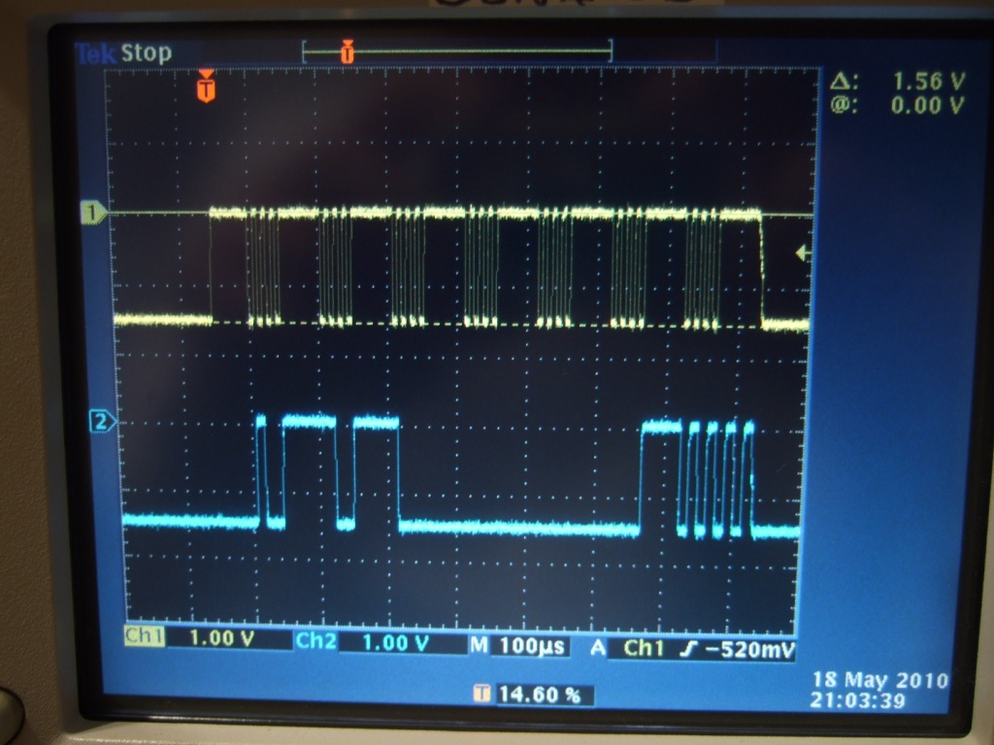

The next is the value in inches on the vernier display for the above. Quite stable but this is in slow transmit mode (every 320 ms) not fast mode.

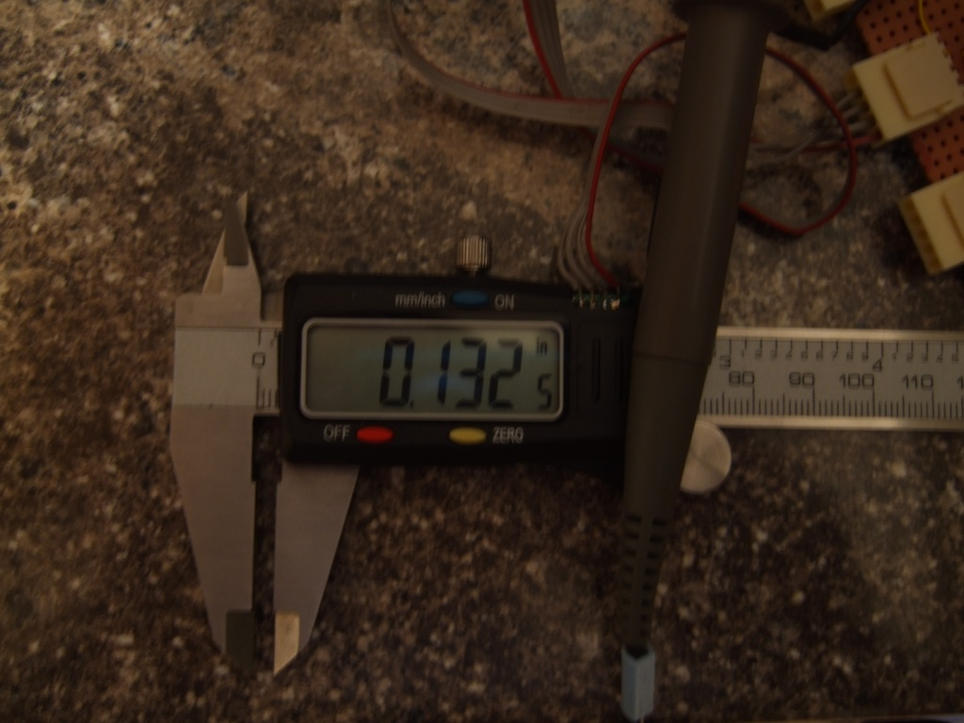

The following shows the packet rate in slow mode (320 ms)

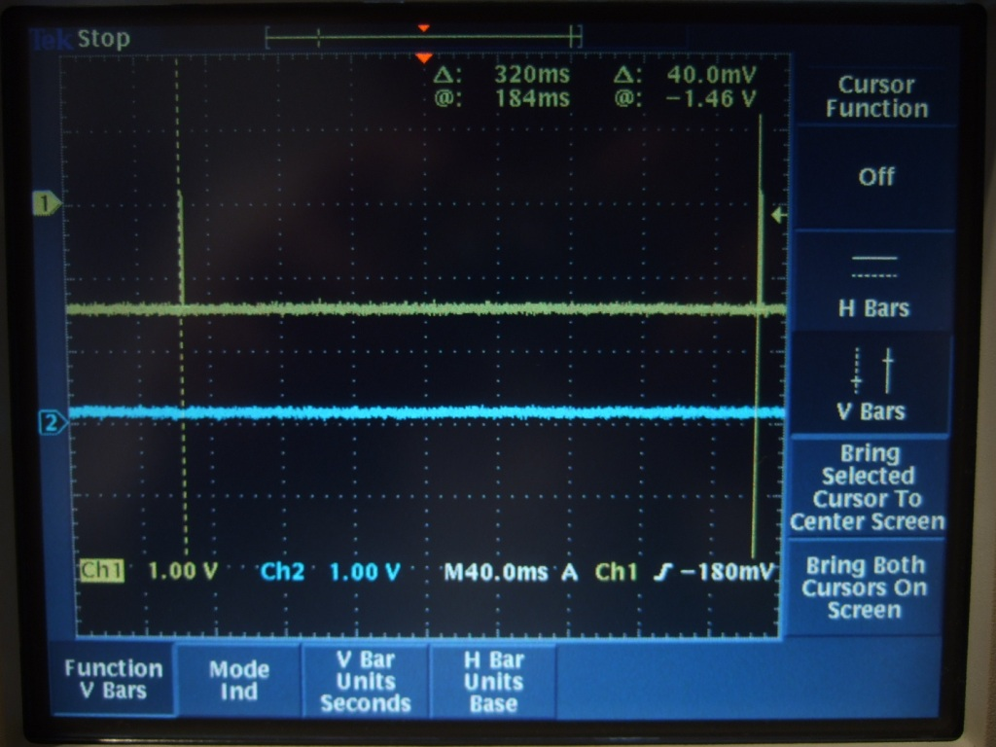

By pressing the Zero on the vernier its possible to select fast mode at 25ms between packets. This makes no difference to the stability of the display on the PC VB6 application – see timing below.

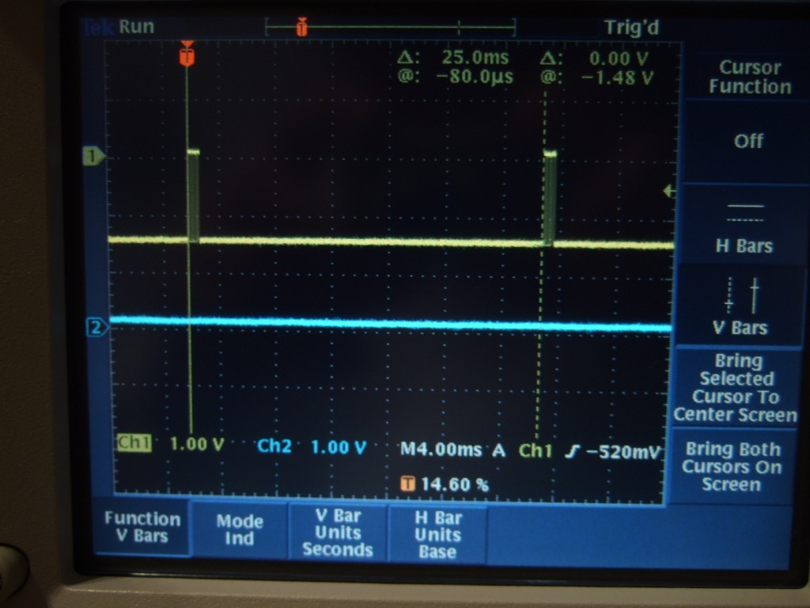

The vernier shows F.T when in FAST mode. As below

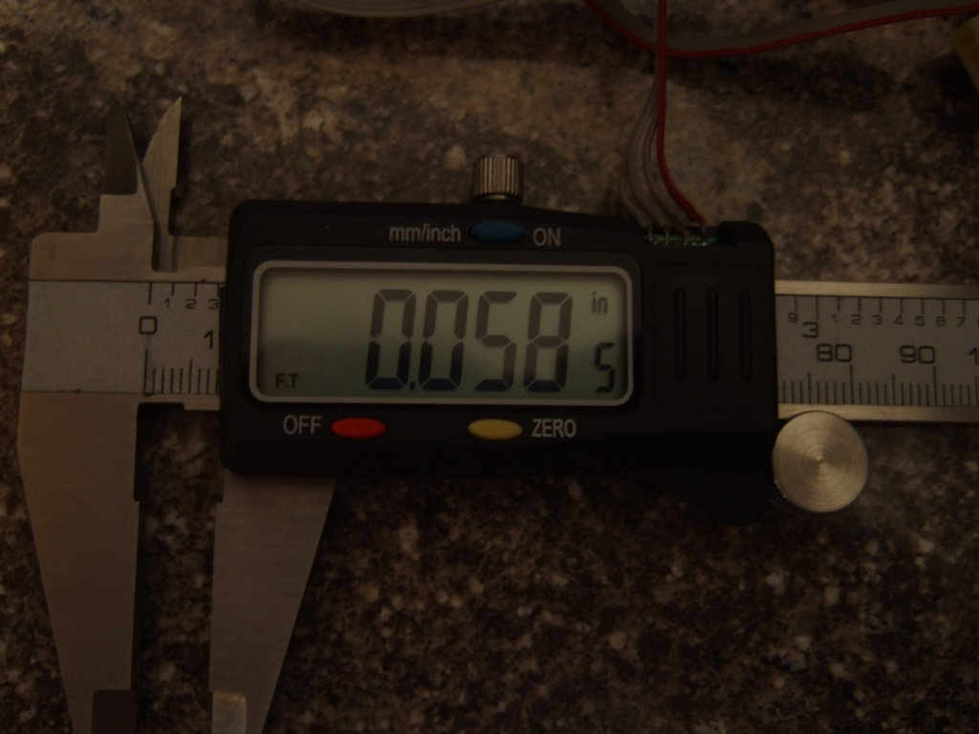

Below is same as above but showing data and clock from the vernier in fast mode. Both good and stable.

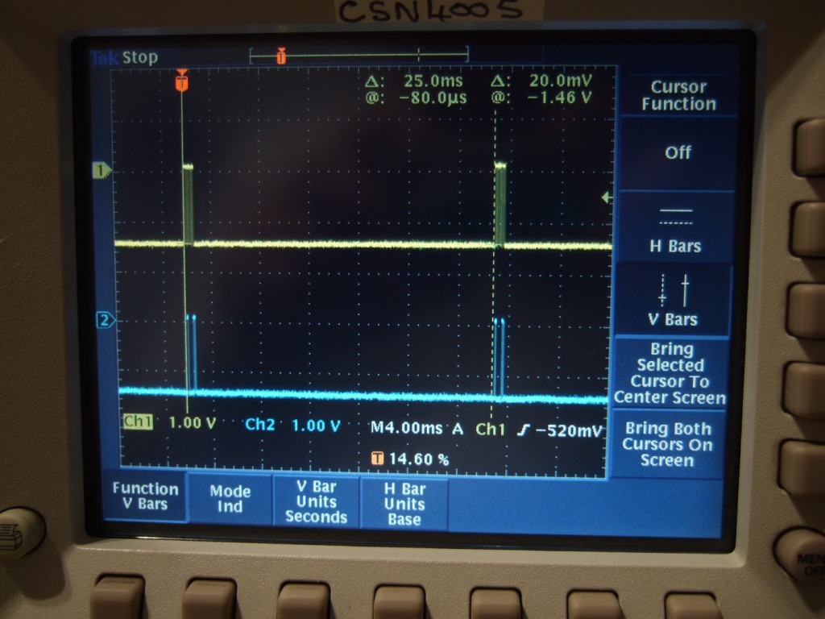

By resetting the abs value in the PC application the interface toggles the data and clock lines to the vernier and the vernier then changes to a zero value display condition as below but H shows in the display. This seems a static value and for once the displayed value on the PC is dead stable at zero. In this mode changing the position of the vernier does not change the local displayed value and/or the displayed value on the PC

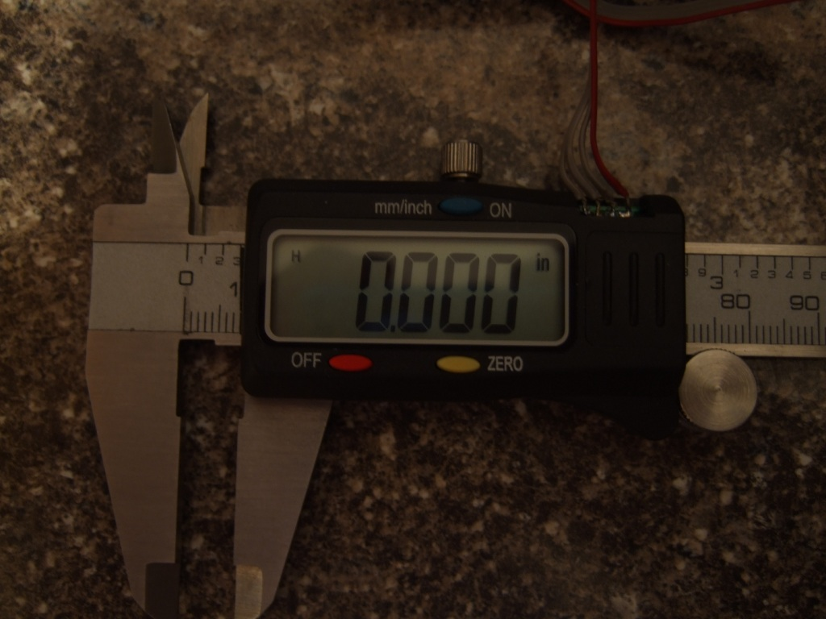

By zeroing again from the PC the Vernier goes to slow update mode and movement causes changes to the displayed value in slow output rate but back to random values on the PC app. Below is the vernier back to working in slow output mode.

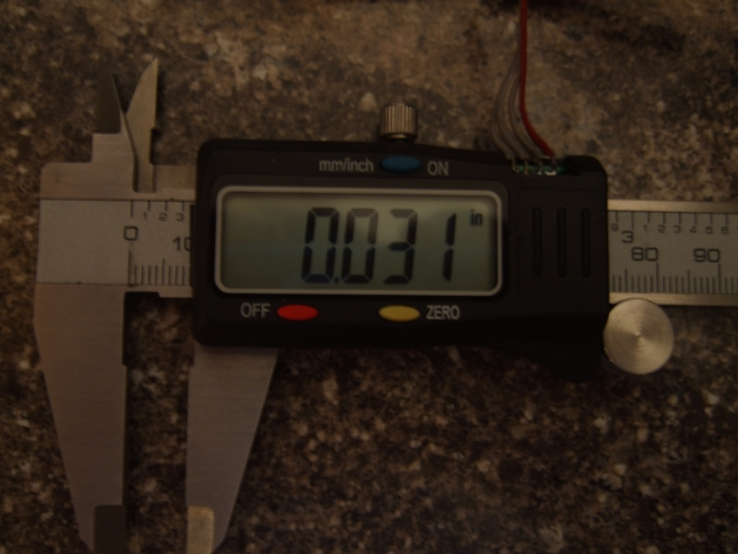

In conclusion I’m now not convinced the vernier remote reset modes are exactly as they should be for my vernier gauge but also not convinced this is the reason for the erratic PC app values.

All power supplies look good and stable and the data bits look healthy on the scope.

I’ve not jet tried a screened RS232 cable.

I’ve not yet tried detailed bit measurement of timing on the packets sent out to the PC

I’ve not tried a 24bit packet output type gauge!!

Below - Back to some TIG welding….. this electronics is driving me mad.
